**Cryptography Final Project**

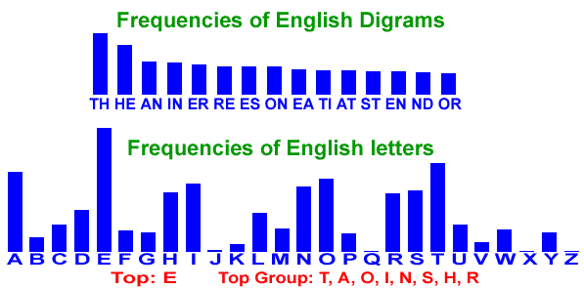

Quite possibly the most valuable tool to a codebreaker is the ability to figure out if some piece of text is bona fide language. Fortunately, English (and others) follow patterns of letter frequency. These can be extremely useful in determining what the plaintext of a message is.

Here is a table of English Letter Frequency.

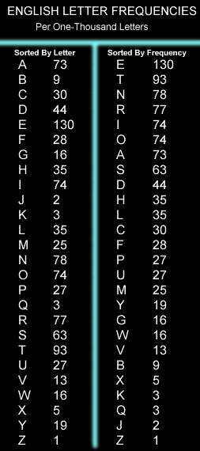

These letters often go together. These are known as digrams.

* th
* he
* at
* st
* an
* in
* ea
* nd
* er
* en
* re
* nt
* to
* es
* on
* ed
* is
* ti

Trigraphs are much like digraphs, but for three letters. Here are the most often seen trigraphs:

* the
* and
* tha
* hat
* ent
* ion
* for
* tio
* has
* edt
* tis
* ers
* res
* ter
* con
* ing
* men
* tho

Letters that are often doubled, as in sni**ff**:

* ll
* tt
* ss
* ee
* pp
* oo
* rr
* ff
* cc
* dd
* nn

The most common letters to end a word:

* e
* t
* s
* d
* n
* r
* y

And finally, the most common words in the English language:

* the
* of
* are
* I
* and
* you
* a
* can
* to
* he
* her
* that
* in
* was
* is
* has
* it
* him
* his

Available Resources:

* Tools and Info: <http://cryptoclub.math.uic.edu>
* Info: <http://www.geocaching.com/seek/cache_details.aspx?guid=395a56a3-61b4-4c29-b413-69374d4c2565>
* Recent Example: <http://en.wikipedia.org/wiki/Kryptos>
* Magic Square: <http://en.wikipedia.org/wiki/Magic_square>
* More puzzles: <http://library.thinkquest.org/28005/flashed/thelab/cryptograms/cryptograms.shtml>